Exercise 3.1.1 · NumPy Array Operations
Creating NumPy arrays from user input, reshaping with ndim, shape, and size attributes.
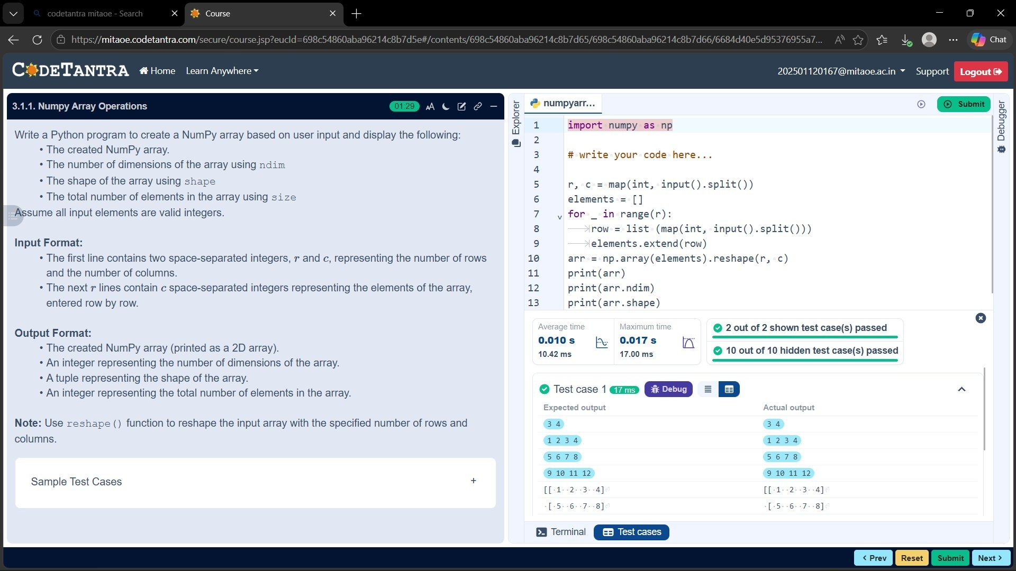

Exercise 3.2.1 · NumPy Matrix Operations
Matrix addition, subtraction, element-wise multiplication, matrix multiplication, and transpose.
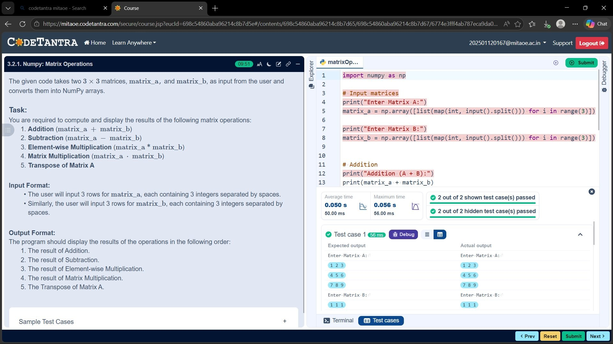

Exercise 3.2.2 · Horizontal & Vertical Stacking
Stacking two 3×3 NumPy arrays side-by-side (hstack) and one-below-the-other (vstack).
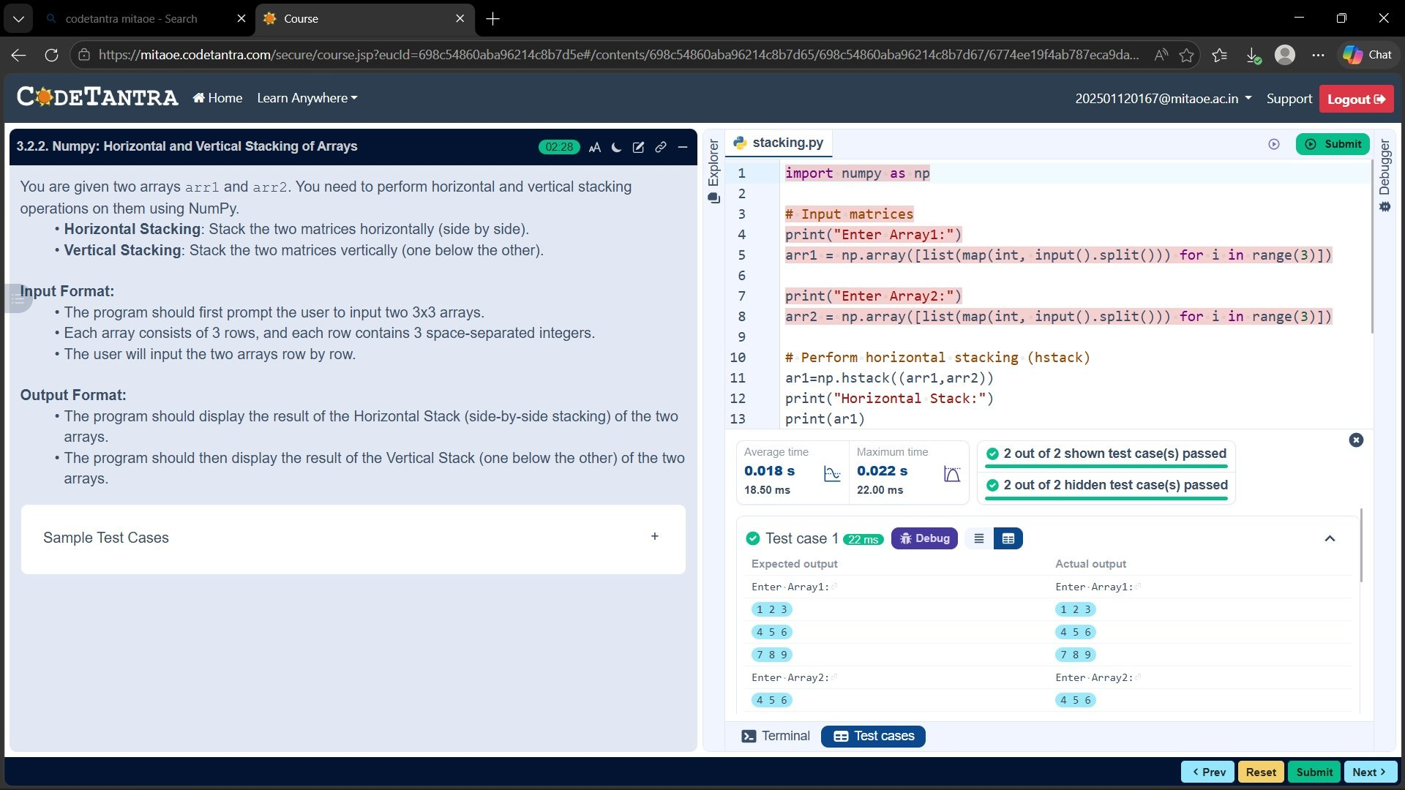

Exercise 3.2.3 · Custom Sequence Generation
Generating custom NumPy sequences using np.arange() with start, stop, and step inputs.
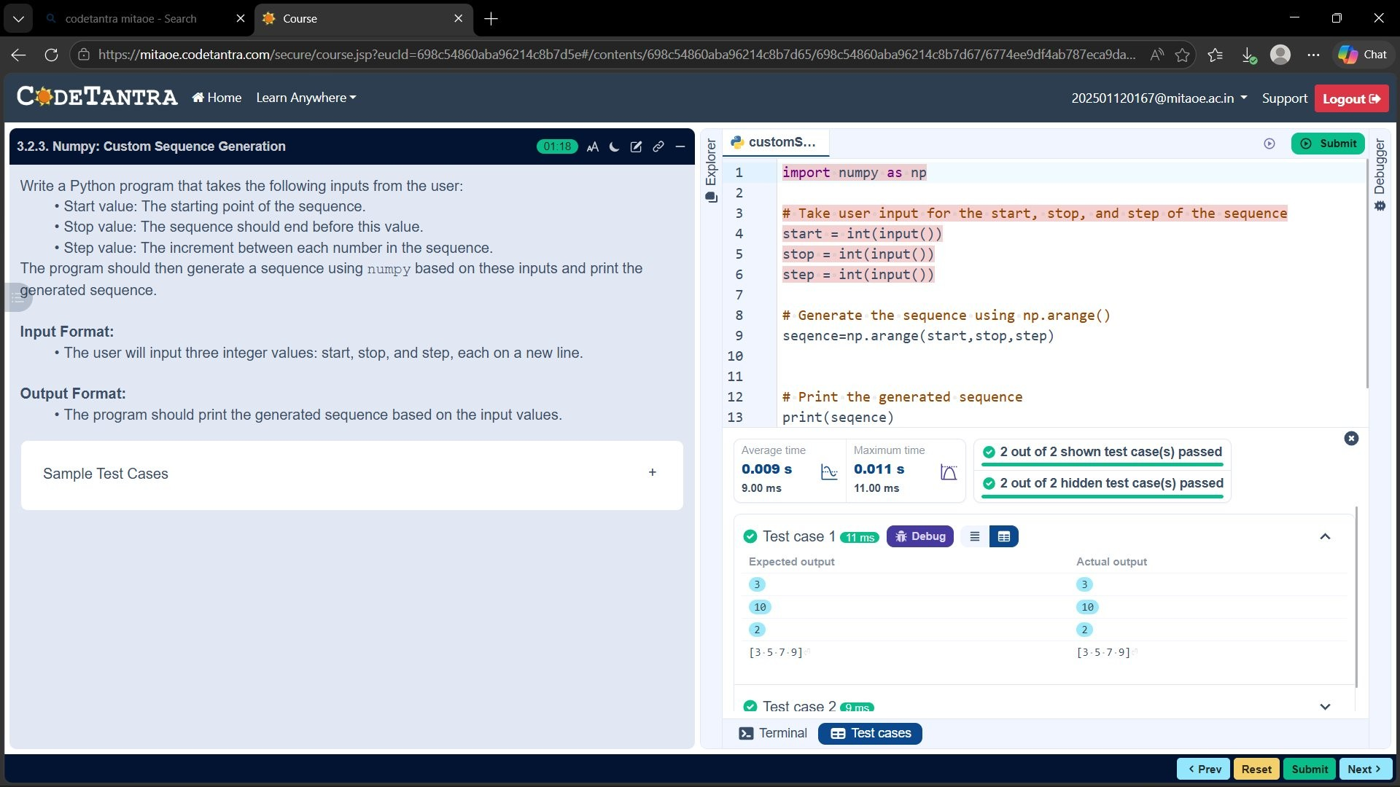

Exercise 3.2.4 · Arithmetic, Statistical & Bitwise Operations
Element-wise ops, mean/median/std, and bitwise AND/OR/XOR on arrays.
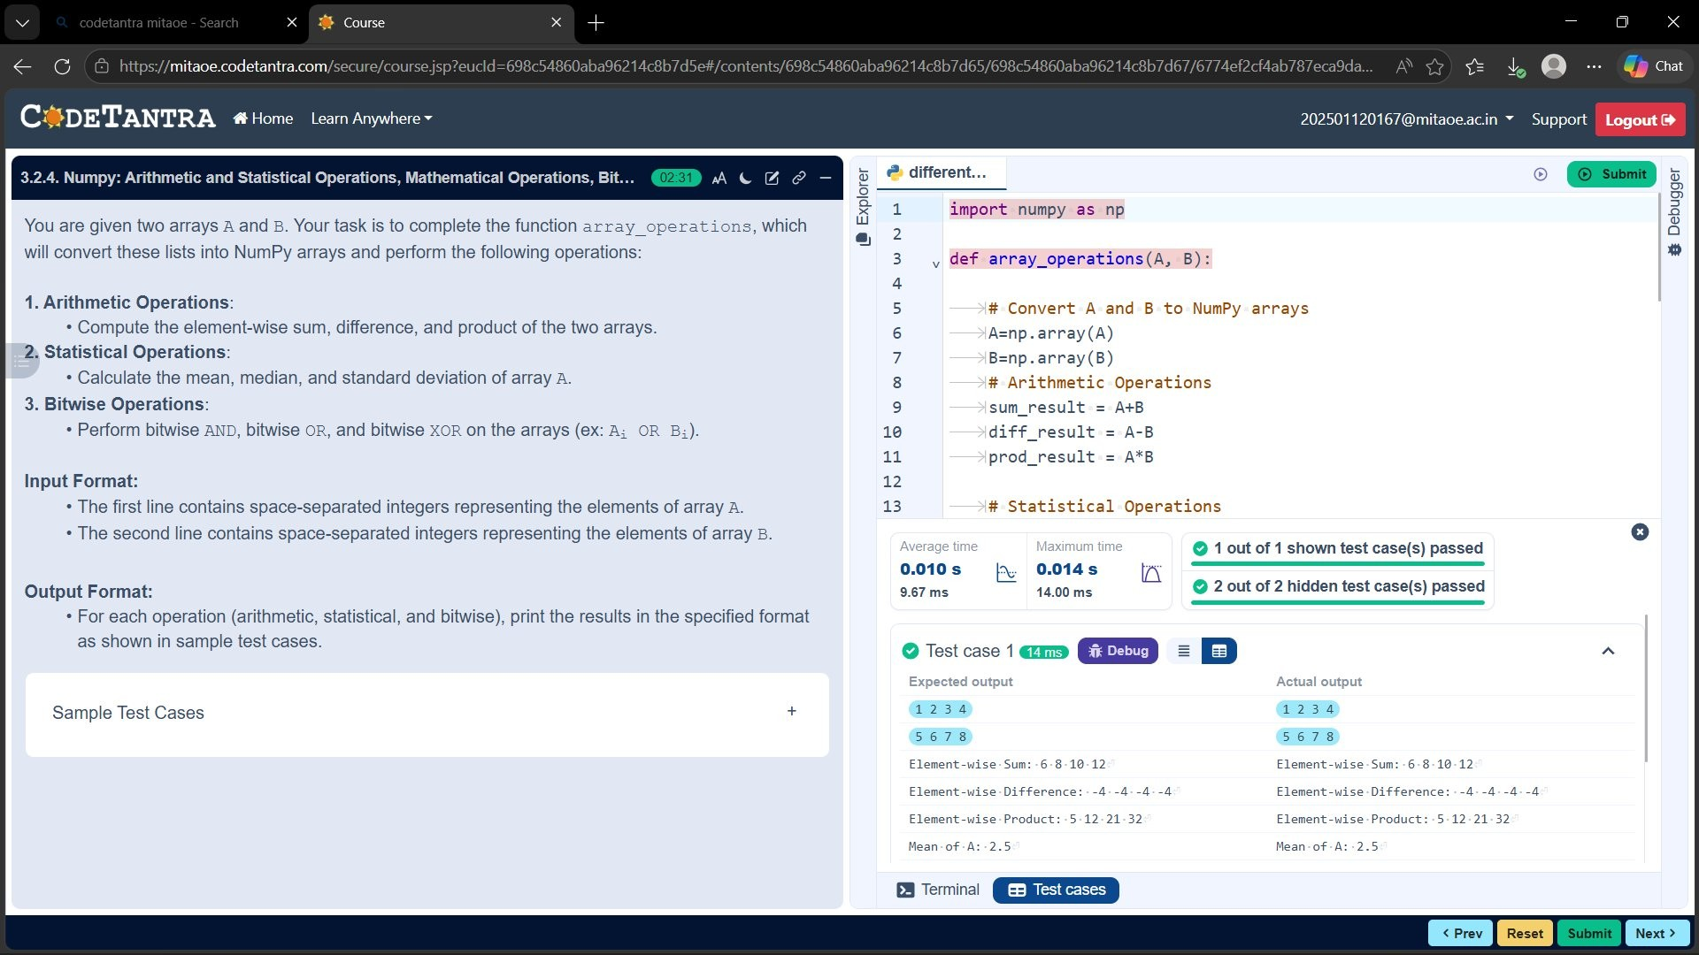

Exercise 3.2.5 · Copying and Viewing Arrays
Understanding view vs copy: modifying a view affects the original; a copy is independent.
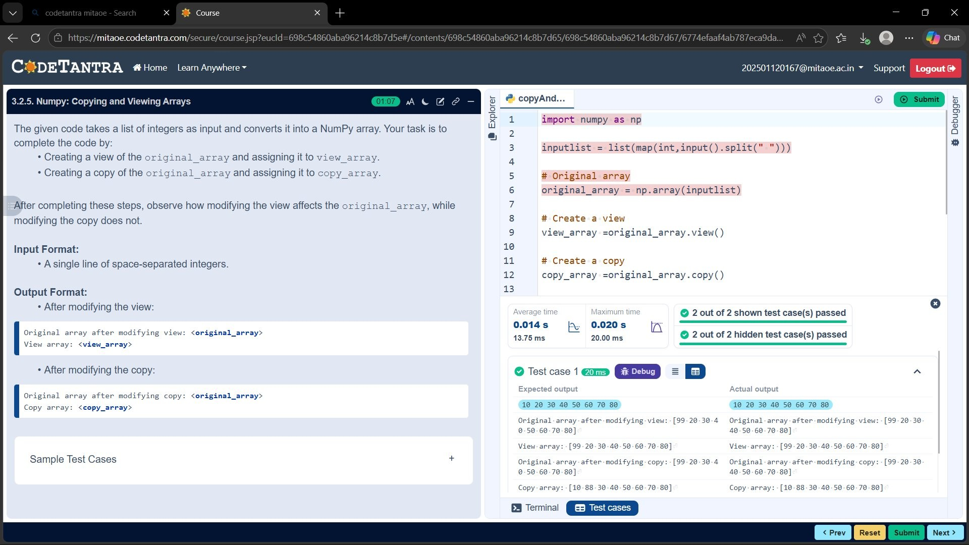

Exercise 3.2.6 · Searching, Sorting, Counting & Broadcasting
Find indices, count occurrences, add via broadcast, and sort arrays in ascending order.
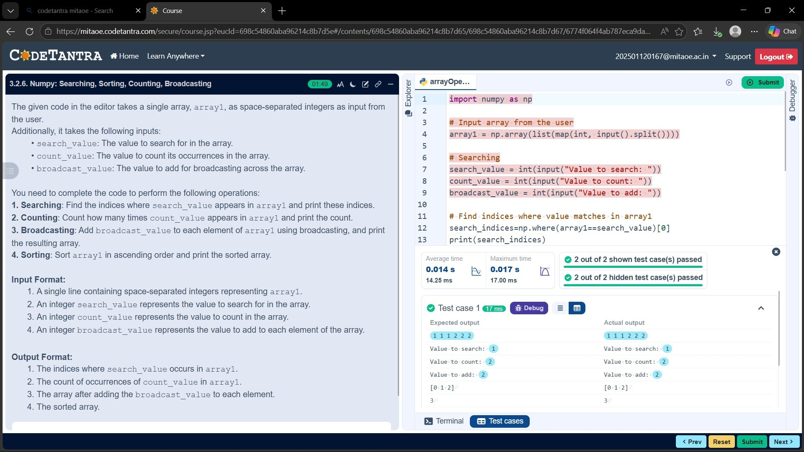

Exercise 3.2.7 · Student Data Analysis and Operations
Reading CSV data with np.loadtxt and performing comprehensive statistical analysis on student marks.
